**A Project Report**

**on**

**COMPLAINT MANAGEMENT SYSTEM IN JAVA**

Submitted as a partial fulfillment of the requirements

For the award of the degree of

**Bachelor of Technology**

**In**

**Computer Science and Engineering**

**Mentor:- Submitted by:-**

Ms. SHALINI SHARMA

**CS Soft Solutions Pvt. Ltd. C-133, Level 1**

**Phase 8, Mohali, Punjab-160062**

**June-July’2016**

**TABLE OF CONTENTS:**

|  |  |  |
| --- | --- | --- |
| **S. No.** | **Topics** | **Page No.** |
| (a) | Certificate |  |
| (b) | Acknowledgement |  |
| (c) | List of Figures |  |
| (d) | List of tables |  |
| **1.** | **Company Profile** |  |
| **2.** | **Project Overview** |  |
| **3.** | **System Analysis** |  |
| **3.1** | **System Objectives** |  |
| **3.2** | **Relation to external environment** |  |
| **3.3** | **Design Consideration Approach** |  |
| **3.4** | **System Architecture** |  |
| **3.5** | **Operational concepts and Scenarios** |  |
| **4.** | **System Specifications** |  |
| **4.1** | **Hardware Requirements** |  |
| **4.2** | **Software Requirements** |  |
| **5.** | **Software Requirement Analysis (SRS)** |  |
| **5.1** | **JAVA** |  |
| 5.1.1 | Characteristics of JAVA |  |
| 5.1.2 | Java Virtual Machine (JVM) |  |
| 5.1.3 | Java Runtime Environment (JRE) |  |
| **5.2** | **MY SQL** |  |
| 5.2.1 | Features of My SQL |  |
| **6.** | **Software Architecture** |  |
| **6.1** | **Socket Overview** |  |
| **6.2** | **UDP Ports** |  |
| **6.3** | **Process Modules** |  |
| 6.3.1 | Graphical User Interface |  |
| 6.3.2 | Resolving Names |  |
| 6.3.3 | Connection |  |
| **6.4** | **Conclusion** |  |
| **7.** | **Software Requirement Specifications** |  |
| **7.1** | **Software Requirement analysis** |  |
| **7.2** | **Software Development Life Cycle** |  |
| 7.2.1 | System Requirement Specifications |  |
| **7.3** | **System Design** |  |
| 7.3.1 | Data Flow Diagrams |  |
| **7.4** | **CMS Components** |  |
| 7.4.1 | Activity Life Cycle |  |
| **8.** | **Testing Module** |  |
| **8.1** | **Testing Objectives** |  |
| **8.2** | **Integration Testing** |  |
| **8.3** | **System testing** |  |
| **8.3.1** | **Logical Testing** |  |
| **8.3.2** | **Functional Testing** |  |
| **8.3.3** | **System Testing** |  |
| **9.** | **Project Layouts** |  |
| **10.** | **Conclusion and Future Scope** |  |
| **11.** | **Bibliography and References** |  |

**ACKNOWLEDGEMENT**

If words are considered as a symbol of approval and token of appreciation then let the words play the heralding role expressing my gratitude.

The satisfaction that accompanies that the successful completion of any task would be incomplete without the mention of the people whose ceaseless cooperation made it possible, whose constant guidance and encouragement crown all efforts with success. We are grateful to our project guide Ms. Shalini Sharma for the guidance, inspiration and constructive suggestions that help us in the preparation of this project. We also thank our colleagues who have helped in successful completion of the project.

**CERTIFICATE**

This is to certify that the project entitled **“COMPLAINT MANAGEMENT SYSTEM APPLICATION IN JAVA”** comprehends the authentic work of in-house summer training accomplished by the student _______________________________

**List of figures:**

**CHAPTER-1**

**Company Profile**

The concerned project has been developed under the supervision and guidance of employees of the company, CS Soft Solutions Pvt. Ltd. This company is located at C-133, Level I, Phase 8, Industrial Area Mohali, Punjab 160055.

**CS Group**

CS Group, founded by Mr. Chhotu Sharma is an amalgam of CS Soft Solutions Pvt. Ltd and CS InfoTech. CS Soft Solutions is a company that provides complete IT solutions with huge clientele all over the world. CS InfoTech is a pioneer institution which is engaged in providing computer education in software technologies, to students as well as professional executives.

**CS Soft Solutions Pvt. Ltd.**

CS Soft Solutions is a complete IT solutions providing company based in Mohali. CS Soft Solutions was established to achieve the goal of providing its clients state-of-art web development services comparable with best in the world. The services provided by CS Soft Solutions Pvt. Ltd. Are

• Web Development

• Web Designing

• Online Marketing

• Mobile Application Development

CS Soft Solutions Pvt. Ltd. was conceptualized in October 2009 by Mr. Chhotu Sharma and Mrs. Shalini Sharma. The goal was to build a company that worked on solid principals, to develop world class IT products and provide a congenial environment and adequately encouraging work culture for all the team members at CS Soft Solutions Pvt. Ltd. Consequently, there is a huge clientele from all across the world. One can get assured of the company by opening the given link:

http://www.cssoftsolutions.com

One of the methods of paying back to the industry that has been adopted by the CS Group is to recruit students from CS InfoTech into CS Soft Solutions Pvt. Ltd. on the basis of their performance and ability to perform in the industry.

**Founders**

Mr. Chhotu Sharma is the founder of the CS Group. He is a Microsoft Certified Software Developer and has been training IT professionals in different Microsoft Technologies since last 13 years. He is recognized as “The Guru of Microsoft Technologies”. For his excellent work in field of education, he has been conferred with title of “Himachal Gaurav” by the Chief Minister, Sh. Prem Kumar Dhumal in the year 2007. His students have been picked up by Fortune 500 companies including Microsoft, Accenture, TCS, Infosys and others. In the year 2009, he established CS Soft Solutions Pvt. Ltd, a company offering complete IT services in multifarious IT applications. He has been instrumental in shaping the goals and evolving values of CS Soft Solutions Pvt. Ltd. His strong penchant for excellence at professional as well as personal front, backed by a sincere and an honest approach towards life are the basic reasons for the success of the ventures he has launched and actively developed. These qualities of sincerity and honesty easily percolate among students, ensuring their success in future lives too.

Mrs. Shalini Sharma is the Director of CS Soft Solutions Pvt. Ltd. and an adept teacher at CS InfoTech. She bears a sharp analytical acumen coupled with excellent People Management skills. She has received Bachelor’s Degree from Guru Nanak Dev University, Amritsar. She has trained thousands of students during the last decade. She has expertise in a wide array of languages and she meticulously imparts technical training to her wards with endeavor to make them fully equipped in dealing with various requirements of the IT industry, in their careers.

**CHAPTER 2-Project Overview**

**ABSTRACT**

The purpose of the this project is to provide the complaints for different products and  getting reply from the products handling teams.

Customers may have complaints about its products. They will be given an email id for each product, where they can send an email when they have a complaint to register. The emails will get converted to complaints and get assigned to the persons handling that product. The complaints can be assigned to different persons and will get tracked to closure. The person handling the complaint will have the facility to communicate with the customer via emails through the system.

An electronics company wants to start campaigns for its new products to be sold to the prospective customers. Campaign means advertising of the products through channels like Tele marketing, letters, signboards, TV Commercials, etc. There are different campaigns for different products and there is a specific period for each campaign.

The Customers of the site, views general information about the   products  and  schemes offered by the company. Customers can login into the application via user email id, where they can  have a complaint to register. Emails will get converted to complaints and get assigned to the persons   handling that complaint. Persons handling the complaint will have a facility to communicate with the customer via emails and mobile numbers through the system. Complainants can track the status of their complaints and can also contact the person through his id details. This system provides a transparent and effective way to handle customer complaints in a better way.

**CHAPTER - 3**

**System Analysis**

**3.1 System Objectives:**

The Complaints Management Project isone of the most significant and resource intensive projects I have undertaken. Its purpose is to encourage and assist public sector agencies in Electronics (both State agencies and local councils) to implement complaints systems that meet recognized standards for good complaints management.

**3.2 Relation to External Environment:**

This tool helps in two major aspects - Resolving the names of all the system connected in a network and enlisting them. Used for registering complaints between multiple systems enlisted in the resolved list.

**3.3Design ConsiderationsApproach:**

The tool has been designed using Netbeans IDE and java methodology: The user interacts with the tool using a GUI.

• The GUI operates in two forms, the register form & the status form.

• The Register form contains the details of user complaint registration.

• The status form makes the actual communication possible in the form of complaint status.

**3.4 System Architecture:**

Theapplication works in two forms-

Register form:In this form the customers can register through email id and password

for their complaints related to the electronics products of the company.

Status form: This form includes the all the description of the complaint ie., from

registering the complaint to status tracking of the complaint. It notifies the

customer of the information about the employee being assigned with the

complaint and his details for the transparency in the system. Reviews fro

the service of the complaint are also welcomed for further more

development of the system.

**3.5 Operational Concepts and Scenarios:**

Operation of the application based on the inputs given by the user:

**System admin module**

The system admin people can login into our system.He want to view his profile and if any new association want  to be created the system admin people can create the new association If he want to modify any association he can delete the association.

**Product admin module**

The product admin can login into the system if any complaints regarding to the particular product he can view that complaint and forward to the corresponding team members .he can view his profile .he can view the messages send by the particular customer

**Product Handling Team Module**

The product handling team module  can login into the system if any complaints regarding to the particular product he can view that complaint and give solution  to the corresponding complaint  .he can view his profile .he can view the messages send by the particular customer .and forward the solution to the particular customer

**Customer Module**

The customer module can login into the system if any complaints regarding to the particular product he can send complaint to regarding admin people  .he can view his profile .he can view the messages send by the particular team handling people  .

**System Interface Module**

 This module can generate the unique id because the complaint is different from the other complaint id by using this we can identify the particular customer and the complaint.

**CHAPTER 4-System Specifications**

**Complaint Management System**

**3.1 Hardware requirements:**

In hardware requirement we require all those components which will provide us the platform for the development of the project. The minimum hardware required for the development of this project is as follows—

**RAM-** minimum 128 MB

**Hard disk-** minimum 5 GB

**Processor-** Pentium 4 and above

Floppy drive and CD drive

These all are the minimum hardware requirement required for our project. We want to make our project to be used in any type of computer therefore we have taken minimum configuration to a large extent.128 MB ram is used so that we can execute our project in a least possible RAM.5 GB hard disk is used because project takes less space to be executed or stored. Therefore minimum hard disk is used. Others enhancements are according to the needs.

**3.2 Software requirements:**

Software’s can be defined as programs which run on our computer. It acts as petrol in the vehicle. It provides the relationship between the human and a computer. It is very important to run software to function the computer. Various Software’s are needed in this project for its development. Which are as follows:

**Operating System-** Windows 7 and above.

**Developing Interface-**Netbeans IDE 7.2

**Others-** Visual Studio

We will be using visual basic as our front hand because it is easier to use and provides features to the users which is used for the development of the project.

**Chapter-5 :Software Requirement Analysis**

**5.1 JAVA**

Java is an object-oriented programming language developed by Sun Microsystems, a company best known for its high-end UNIX workstations. Modeled after C++, the Java language was designed to be small, simple, and portable across platforms and operating systems. It is intended to let application developers "[write once, run anywhere](http://en.wikipedia.org/wiki/Write_once,_run_anywhere)" (WORA), meaning that code that runs on one platform does not need to be recompiled to run on another. Java applications are typically [compiled](http://en.wikipedia.org/wiki/Compiler) to [byte-code](http://en.wikipedia.org/wiki/Java_bytecode) ([class file](http://en.wikipedia.org/wiki/Class_(file_format))) that can run on any [Java virtual machine](http://en.wikipedia.org/wiki/Java_virtual_machine) (JVM) regardless of [computer architecture](http://en.wikipedia.org/wiki/Computer_architecture). Java was originally developed by [James Gosling](http://en.wikipedia.org/wiki/James_Gosling) at [Sun Microsystems](http://en.wikipedia.org/wiki/Sun_Microsystems)(which has since [merged into Oracle Corporation](http://en.wikipedia.org/wiki/Sun_acquisition_by_Oracle)) and released in 1995 as a core component of Sun Microsystems' [Java platform](http://en.wikipedia.org/wiki/Java_(software_platform)). The language derives much of its [syntax](http://en.wikipedia.org/wiki/Syntax_(programming_languages)) from [C](http://en.wikipedia.org/wiki/C_(programming_language)) and [C++](http://en.wikipedia.org/wiki/C%2B%2B), but it has fewer [low-level](http://en.wikipedia.org/wiki/Low-level_programming_language) facilities than either of them.

### 5.1.1 Characteristics of Java

The target of Java is to write a program once and then run this program on multiple operating systems.

Java has the following properties:

* Platform independent: Java programs use the Java virtual machine as abstraction and do not access the operating system directly. This makes Java programs highly portable. A Java program (which is standard complaint and follows certain rules) can run unmodified on all supported platforms, e.g. Windows or Linux.
* Object-orientated programming language: Except the primitive data types, all elements in Java are objects.
* Strongly-typed programming language: Java is strongly-typed, e.g. the types of the used variables must be pre-defined and conversion to other objects is relatively strict, e.g. must be done in most cases by the programmer.
* Interpreted and compiled language: Java source code is transferred into the bytecode format which does not depend on the target platform. These bytecode instructions will be interpreted by the Java Virtual machine (JVM). The JVM contains a so called Hotspot-Compiler which translates performance critical bytecode instructions into native code instructions.
* Automatic memory management: Java manages the memory allocation and de-allocation for creating new objects. The program does not have direct access to the memory. The so-called garbage collector deletes automatically objects to which no active pointer exists.

### Java Virtual machine

The Java virtual machine (JVM) is a software implementation of a computer that executes programs like a real machine. The Java virtual machine is written specifically for a specific operating system, e.g. for Linux a special implementation is required as well as for Windows. Java programs are compiled by the Java compiler into byte-code. The Java virtual machine interprets this byte-codeand executes the Java program.

### 

### Java Runtime Environment vs. Java Development Kit

A Java distribution comes typically in two flavors, the Java Runtime Environment (JRE) and the Java Development Kit (JDK). The Java runtime environment (JRE) consists of the JVM and the Java class libraries and contains the necessary functionality to start Java programs. The JDK contains in addition the development tools necessary to create Java programs. The JDK consists therefore of a Java compiler, the Java virtual machine, and the Java class libraries.

**5.2 My SQL**

**MySQL** is currently the most popular open source database server in existence. On top of that, it is very commonly used in conjunction with PHP scripts to create powerful and dynamic server-side applications. MySQL is a fast, easy-to-use RDBMS being used for many small and big businesses. MySQL is developed, marketed, and supported by MySQL AB, which is a Swedish company. MySQL is becoming so popular because of many good reasons:

* MySQL is released under an open-source license. So you have nothing to pay to use it.
* MySQL is a very powerful program in its own right. It handles a large subset of the functionality of the most expensive and powerful database packages.
* MySQL uses a standard form of the well-known SQL data language.
* MySQL works on many operating systems and with many languages including PHP, PERL, C, C++, JAVA, etc.
* MySQL works very quickly and works well even with large data sets.
* MySQL is very friendly to PHP, the most appreciated language for web development.
* MySQL supports large databases, up to 50 million rows or more in a table. The default file size limit for a table is 4GB, but you can increase this (if your operating system can handle it) to a theoretical limit of 8 million terabytes (TB).
* MySQL is customizable. The open-source GPL license allows programmers to modify the MySQL software to fit their own specific environments.

**5.2.1 Features of MY SQL:**

* **Scalability and Flexibility:**The MySQL database server provides the ultimate in scalability, sporting the capacity to handle deeply embedded applications with a footprint of only 1MB to running massive data warehouses holding terabytes of information.
* **High Performance:**A unique storage-engine architecture allows database professionals to configure the MySQL database server specifically for particular applications, with the end result being amazing performance results. Whether the intended application is a high-speed transactional processing system or a high-volume web site that services a billion queries a day, MySQL can meet the most demanding performance expectations of any system.
* **Robust Transactional Support:**MySQL offers one of the most powerful transactional database engines on the market. Features include complete ACID (atomic, consistent, isolated, durable) transaction support, unlimited row-level locking, distributed transaction capability, and multi-version transaction support where readers never block writers and vice-versa.
* **Web and Data Warehouse Strengths:**MySQL is the de-facto standard for high-traffic web sites because of its high-performance query engine, tremendously fast data inserts capability, and strong support for specialized web functions like fast full text searches. These same strengths also apply to data warehousing environments where MySQL scales up into the terabyte range for either single servers or scale-out architectures.
* **Comprehensive Application Development:**One of the reasons MySQL is the world's most popular open source database is that it provides comprehensive support for every application development need. Within the database, support can be found for stored procedures, triggers, functions, views, cursors, ANSI-standard SQL, and more.
* **Open Source Freedom and 24 x 7 Support:**Many corporations are hesitant to fully commit to open source software because they believe they can't get the type of support or professional service safety nets they currently rely on with proprietary software to ensure the overall success of their key applications. The questions of indemnification come up often as well. These worries can be put to rest with MySQL as complete around-the-clock support as well as indemnification is available through MySQL Network.

**Chapter-6**

**SOFTWARE ARCHITECHTURE**

**6.1 Socket Overview:**

A socket is an object that represents a low level access point to the IP stack. This socket can be opened or closed or one of a set number of intermediate states. A socket can send and receive data down disconnection. Data is generally sent in blocks of few kilobytes at a time for efficiency; each of these block are called a packet. All packets that travel on the internet must use the Internet Protocol. This means that the source IP address, destination address must be included in the packet. Most packets also contain a port number. A port is simply a number between 1 and 65,535 that is used to differentiate higher protocols. Ports are important when it comes to programming your own network applications because no two applications can use the same port. Packets that contain port numbers come in two flavors: UDP and TCP/IP. UDP has lower latency than TCP/IP, especially on startup. Where data integrity is not of the utmost concerned, UDP can prove easier to use than TCP, but it should never be used where data integrity is more important than performance; however, data sent by UDP can sometimes arrive in the wrong order and be effectively useless to the receiver. TCP/IP is more complex than UDP and has generally longer latencies, but it does guarantee that data does not become corrupted when travelling over the internet. TCP is ideal for file transfer, where a corrupt file is more unacceptable than a slow download; however, it is unsuited to internet radio, where the odd sound out of place is more acceptable than long gaps of silence.

**6.2 UDP Ports:**

The User Datagram Protocol is an unreliable, connectionless oriented protocol that uses an IP address for the destination host and a port number to identify the destination application. The UDP port number is distinct from any physical port on a computer such as an I/O port address. The UDP port is a 16-bit address that exists only for the purpose of passing certain types of datagram information to the correct location above the transport layer of the protocol stack. A UDP datagram header consists of four fields of two bytes each: 1. Source port number 2. Destination port number 3. Datagram size 4. Checksum

**6.3 Process Modules:**

The functionalities and responsibilities of the system were partitioned and then assigned to subsystems or components as described below.

**6.3.1 Graphical User Interface-** The user interface that the software provides to the user is interactive. It provides two different forms, one for list of systems and the other for the actual text chatting.

**6.3.2 Resolving Names-** This module handles the code that is necessary to view the different aspects of the network connections in a system. It uses “net.exe” to resolve the names of the system connected to a network to which the host system is also connected. It then enlists these names into the first form of the application.

**6.3.3 Connection-** This module deals with the establishment of a connection between the host system and the system selected from the list. The connection is made by the help of sockets that uses ports to send and receive packets from one system to another. The message sent or received is coded and is encoded or decode respectively.

**6.4 Conclusion:**

This chapter has given a broad picture of the design of the software in terms of the different modules used. It also gives us an idea about the degree to which each module performs related tasks. We also get an idea about the interdependence among the modules.

**Chapter-7: Software Requirement Specifications (SRS)**

**Software Requirement Analysis**

The software requirement specification is produced at the culmination of the analysis task. The function and performance allocated to software as part of system engineering are refined by establishing a complete information description, a detailed functional description, a representation of system behavior, an indication of performance requirement and design constraints appropriate validation criteria, and other information pertinent to requirement.

The introduction to software requirements specification states the goals and objectives of the software, describing it in the context of the computer based system. The Information Description provides a detailed description of the problem that the software must solve. Information content, flow and structure are documented.

A description of each function required to solve the problem is presented in the Functional Description. Validation Criteria is probably the most important and ironically the most often neglected section of the software requirement specification. Software requirement specification can be used for different purpose. Here are the major uses.

**Feasibility Study**

**Introduction**

Prior to stating whether the system we have to develop is feasible or not we believe that we should emphasize on what is implied by the word “Feasibility”. Feasibility is the measure of how beneficial or practical the development of the system will be to the organization. It is a preliminary survey for the systems investigation. It aims to provide information to facilitate a later in-depth investigation.

**Types:-**

There are various measures of feasibility that helps to decide whether a particular project is feasible or not. These measures include –

* + - **Operational Feasibility**
    - **Technical Feasibility**
    - **Economical Feasibility**

**Existing System:**

The existing Complaint Management system, In Existing System Customers of the Organization has to Visit the Organization Whenever they have any Complaints regarding the Products of the Organization, This wastes lot Of time

Whenever a customer of the bank requires service from the bank he required moving to the bank and then he required to submit the compliant to the specified officer. The problem is written in paper and will be submitted at the bank. Then the manager will look after it and then he will take care about the customer’s problems. After that the manager will enquire and allocate the problem to the specified person in that department. The person will enquire the problem and then rectifies it.

**Limitations in Existing System :**

* Here in the existing system the customers need to visit the organization.
* The current system is very slow in access.
* The complete current system is manual system and it will not provide any kind of security to the data.

**Proposed System :**

In the proposed system we have the following new implementations: Users of the system, Customers of the Complaint Management System. Here again any number of groups can be assumed. The complaints can be assigned to different persons and will get tracked to closure. The person handling the complaint will have the facility to communicate with the customer via emails through the system.

The proposed system is automated process of sending request through the web based system. The complaints can be sent easily by the customer from any where. The services are given through the system are through the email.

**Advantages over Existing System :**

The Advantages of the proposed system are:

* The proposed system is completely automated system
* The customers can easily access there database
* The email facility provides the customer interaction
* This also provides security for the customer information

**Economical Feasibility**

In making recommendations a study of the economics of the proposed system should be made.

Even though finding out the costs of the proposed project is difficult we assume and estimate the costs and benefits as follows.

According to the computerized system we propose, the costs can be broken down in two categories.

1. Costs associated with the development of the system.

2. Costs associated with operating the system.

**7.2 Software Development Life Cycle**

SDLC stands for System Development Life Cycle or Software Development Life Cycle. It is used to describe functional systems development activity, to gain control of the complexities of systems development, and to ensure the needs of customers and users are the basis for technical activity. The SDLC has made a great impact on developing information systems as a general approach. Stages of the SDLC may vary from different references, for instance, “conventional systems analysis”, “traditional systems analysis”, “classical life cycle model”, “linear sequential model” and “waterfall model”. However, the most similar point is that they all start from the feasibility study stage and end at the review stage.

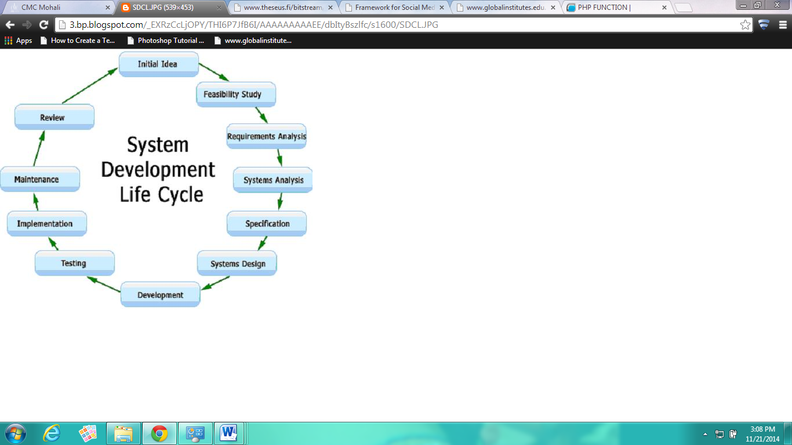

**7.2.1 System Requirement Specification (SRS)**

SRS document is a specification for a particular software product that performs certain functions in a specific environment. Every engineered and manufactured product must be specified in some fashion.

When the system application approach is application lied to the development of information system solution, a multi-step cycle emerge, which is SDLC. System Development Life Cycle is a cyclic process in which information is conceived, designed and implemented for fulfilling needs of end user. System Development basically consists of two major steps i.e., System analysis and design. Besides this, it involves several distinct phases, each of which often must be complete before a subsequent task can begin.

Thus, SDLC method is classically thought of as a set of activities that analyst, designer and user carry out to develop and implement an information system. It is not a procedure that deals with hardware and software, rather, it is building a computer based system to help the user to operate a business or make decisions effectively and manage an enterprise successfully.

SDLC is an organized way to build an information system. It involves development of candidate system i.e. a newly developed system. To replace currently existing system for better working the task of designing a system is divided into series of phases.

The SRS document is when completed serves as a contract between client and developer. The more attention is given to the SRS document the more accurate and precise the SRS document and the better the quality of the final product.

**7.3 System Design**

**Data Flow Diagrams**

In our DFD, we give names to data flows, processes, and data stores. Although the names are descriptive of the data, they do not give details. So the following the DFD, our interest is to build some structured place to keep details of the contents of data flow, processes, and data store. A data dictionary is a structured repository of data about data. It is a set of rigorous definition of all DFD data element and data structure

**DFD Symbols**

In the DFD, there are five symbols,

* **A Square** defines a source (originator) or destination of system data.
* **An Arrow** identifies data flow- data in motion .It is pipeline through which information flows.
* **A circle** or a **bubble** (or a oval bubble) represents a process that transforms incoming data flow(s) into outgoing data flow(s)
* **An Open rectangle** is a data store-data at rest, or temporary repository of data.
* **A HORIZONTAL LINE**represents data stored or data at rest or a temporary rest repository of data.
* The DFD was first developed by “Larry Constantine” as a way of expressing system requirements in a graphical form. A DFD, also referred to as a bubble chart has a purpose of clarifying system requirements and identifying major transformations that will become the program in this system design.

**DFD FOR COMPLAINT MANAGEMENT SYSYTEM**

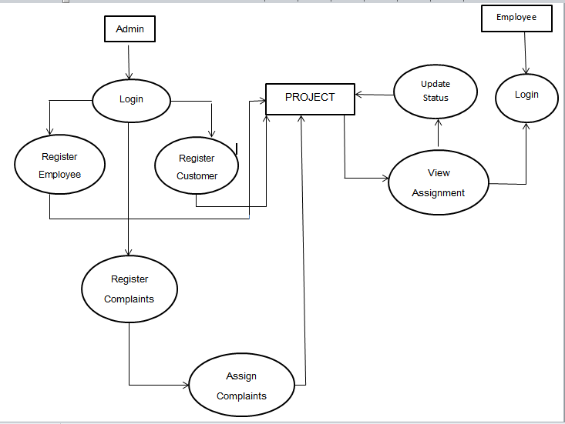

**7.4 Project: Complaint Management System**

**CMS Components:**

Java’s application framework lets you create rich and innovative application using a set of reusable components. This section explains how you can build the components that define the building blocks of your app and how to connect them together using intents.

**Activity Life Cycle**

Launching an activity can be quite expensive. It may involve creating a new Linuxprocess, allocating memory for all the UI objects, inflating all the objects from XMLlayouts, and setting up the whole screen. Since we’re doing a lot of work to launch anactivity, it would be a waste to just toss it out once the user leaves that screen. To avoidthis waste, the activity life cycle is managed via Activity Manager.Activity Manager is responsible for creating, destroying, and managing activities. Forexample, when the user starts an application for the first time, the Activity Managerwill create its activity and put it onto the screen. Later, when the user switches screens,the Activity Manager will move that previous activity to a holding place. This way, ifthe user wants to go back to an older activity, it can be started more quickly. Olderactivities that the user hasn’t used in a while will be destroyed in order to free morespace for the currently active one. This mechanism is designed to help improve thespeed of the user interface and thus improve the overall user experience.It is a managed,container-based environment similar to programming for Java applets or servlets. So,when it comes to an activity life cycle, you don’t get to say what state the activity is in,but you have plenty of opportunity to say what happens during the transitions fromstate to state. The following figure shows the states that an activity can go through.

Fig: ACTIVITY LIFE CYCLE :



**Chapter-8: Testing Module**

**PROJECT TESTING**

Testing of a developed system is an important implementation activity. System testing and debugging computer programs and testing information processing procedures

**8.1 Testing Objectives:**

Unit testing is the testing of the individual components (units) of the software. Unit testing is conducted as part of a combined code and unit test phase of the software lifecycle, although it is not uncommon for coding and unit testing to be conducted as two distinct phases. When developing a strategy for unit testing, there are three basic organizational approaches that can be taken. These are top down, bottom up and isolation. In our case of CMS Application we simply use top down approach. There are two sub options in our project first one is Form1 mode, which is the listing part and second one is Form2 mode which is complaint registration form . In the first case we just test for the correct resolution of names of users and employees registered with the company. And in the second mode our motive is to obtain a two way communication between the user and employee via admin assigning complaints to the employees accordingly to the locations of the complaint registered. And we are very much successful here in our test case.

**8.2 Integration Testing:**

After the unit testing we have to perform integration testing. The goal here is to see if modules can be integrated properly, the emphasis being on testing interfaces between modules. After the modules are connected we have perform the total testing.

**8.3System Testing:**

System testing is the process of executing software in a controlled manner, in order to answer the questions "Does the software behave as specified system testing is often used in association with the terms verification and validation .Verification is the checking of items, including software, for conformance and consistency with an associated specification. Software testing is just one kind of verification, which also uses techniques such as reviews, analysis, inspections and walkthroughs. Validation is the process of checking that what has been specified is what the user actually wanted. The test strategies will include different types of testing as describes below:

**8.3.1 Logical Testing-** This will be used to test every aspect of both modes, report and query as soon as it is implemented, using valid, invalid and extreme data test data will be added to test each code module and results compared with the expected results. Sufficient data will be added to ensure that there is at least one entry in each category. Subsequent tests will often involved adding new data, which will be deleted when the test works satisfactorily. As per our requirement we have also included some field such as character size etc and then queries were performed after that results were tabulated and then the module were free from extra field**.**

**8.3.2 Functional Testing-** In this menu items were tested to ensure no functions has been missed out. This is done for the smooth working of the project.

**8.3.3 System Testing-** This is done after the completion of system; all the queries were carried out again to ensure that no errors have been introduced.

**CHAPTER 9**

**CONCLUSION AND FUTURE SCOPE**

In future we’ll work with them together so that the youth can relate the check ins and movies at the same time and at the same place.

**Project Screenshots**

CMS Login :

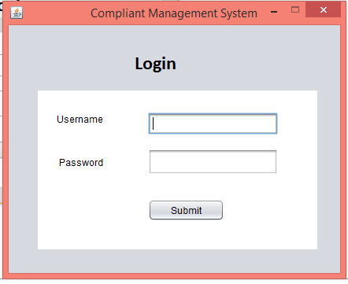

Admin Home:

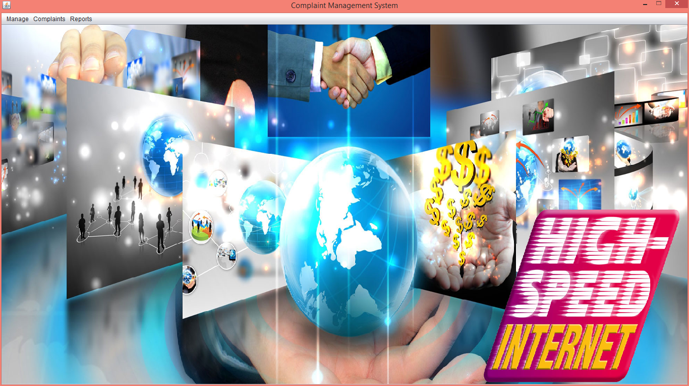

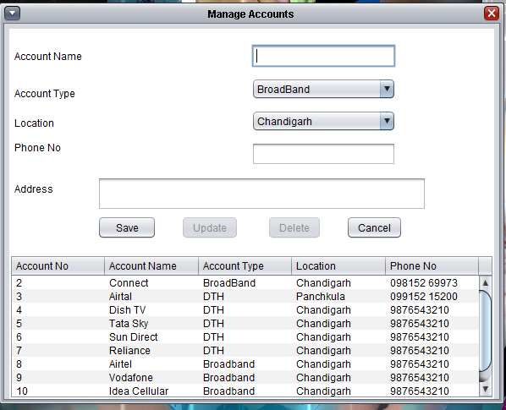Manage Account after login :

Manage Employee After Login :

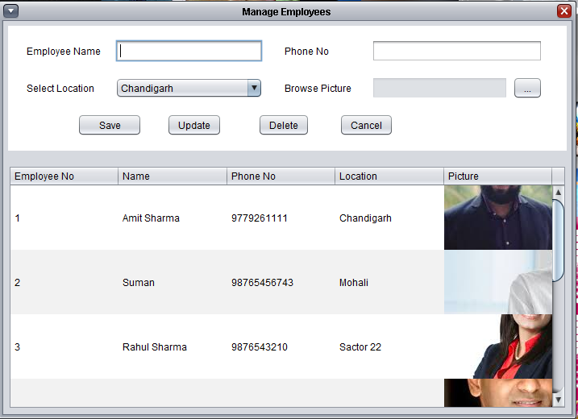

Register Complaint :

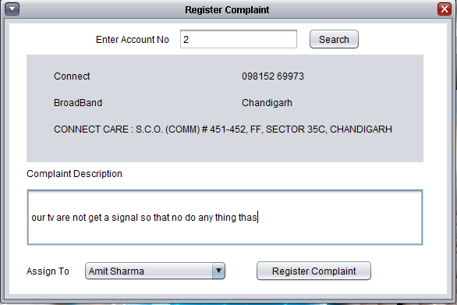

Complaints Of The Months :

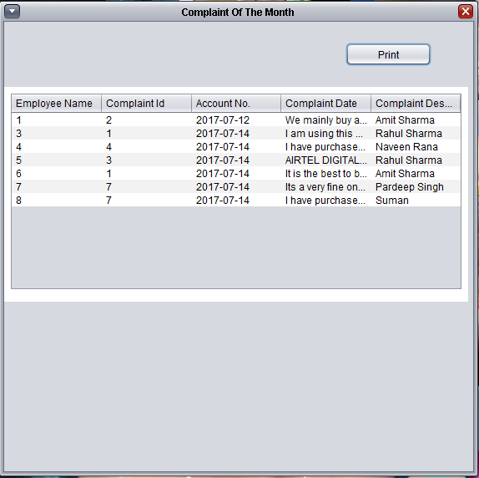

Complaint Visiting Employee Module :

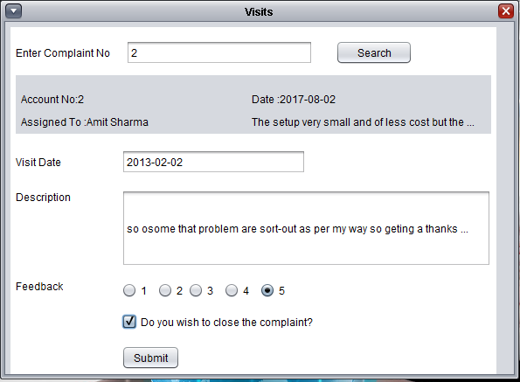

Display Performance Report :

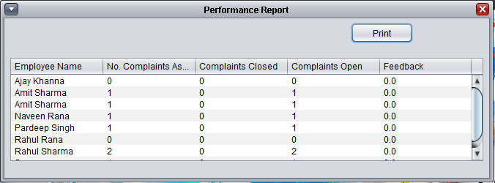

Complaints Handled by Employee Status :

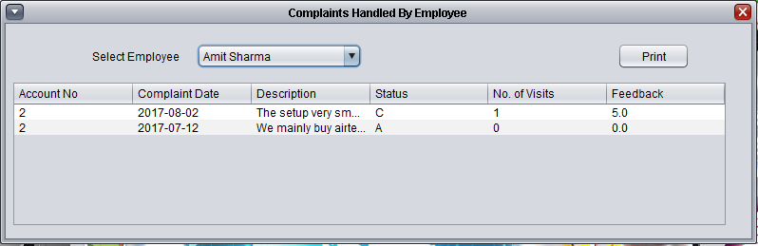

**Data base Snapshots**

Project Table :

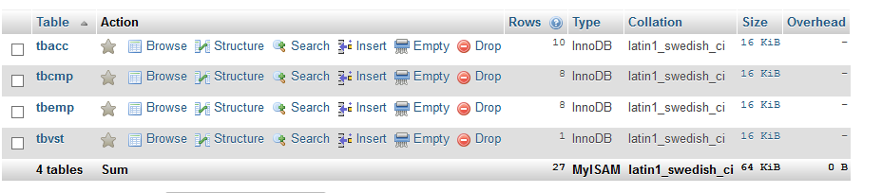

Table 1 (Complaint Table) :

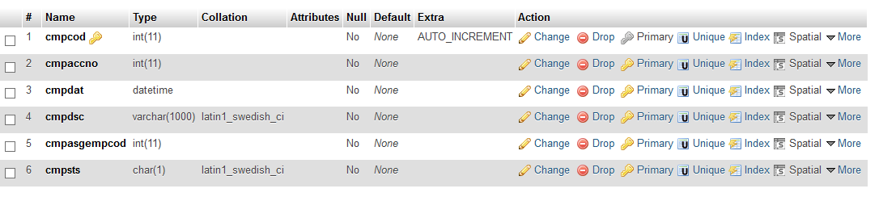

Table 2 (Visit table):

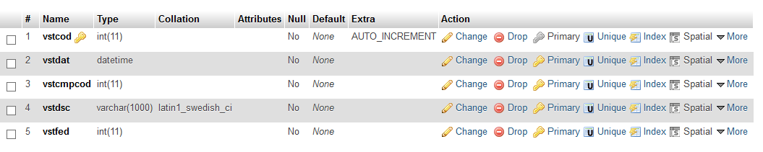

Table 3 (Employee table) :

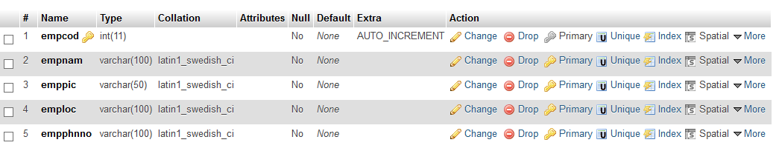

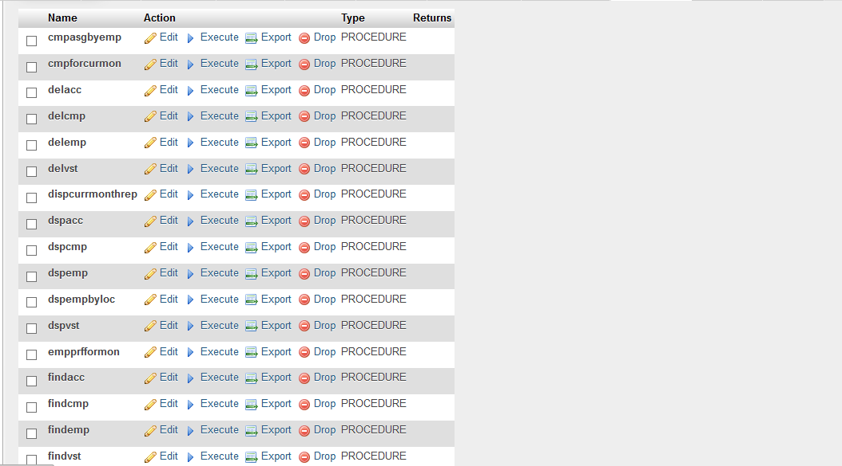Routines:

**CHAPTER 9**

**BIBLIOGRAPHY AND REFRENCES**

**BOOKS**

* 1. Oreily Learning Android
  2. Apress Beginning Android
  3. Wrox Beginning Android 4

**REFRENCES**

http://www.javapoint.com/tutorals/

http://www.vogella.com/tutorials/